Roadmap

Title: Explainable Data Analytics for Sustainable Smart City Applications

Domain
Smart City Analytics

Dataset

Air Quality Monitoring Dataset (Environmental and Air Pollution Analytics)

Source: https://www.kaggle.com/datasets/ziya07/air-quality-dataset

This dataset contains air pollution and environmental parameters such as PM2.5, PM10, NO₂, SO₂, CO, Temperature, and Humidity. It is used to analyze air quality patterns, monitor pollution levels, and support sustainable environmental management.

This dataset will be used for:

Air Quality Analysis

Pollution Trend Analysis

Environmental Pattern Identification

Explainable Air Quality Prediction

2. Historical Weather Dataset (Climate and Weather Analytics)

Source: https://www.kaggle.com/datasets/zulqarnain11/synthetic-weather-dataset

This dataset contains historical weather information, including temperature, humidity, wind speed, pressure, and precipitation. It is used to analyze weather patterns and study their impact on air quality and energy consumption.

This dataset will be used for:

Weather Pattern Analysis

Climate Trend Analysis

Weather Impact on Air Quality

Weather-based Predictive Analytics

3. Energy Consumption Dataset (Smart Energy Analytics)

Source: https://www.kaggle.com/datasets/mrsimple07/energy-consumption-prediction

This dataset contains energy usage data along with environmental and operational factors such as temperature, occupancy, HVAC usage, lighting usage, and renewable energy. It is used to analyze energy consumption patterns and predict future energy demand for sustainable energy management.

This dataset will be used for:

Energy Consumption Analysis

Energy Demand Prediction

Sustainable Energy Management

Smart City Energy Analytics

Abstract

Rapid urbanization has resulted in several challenges, including increasing air pollution, unpredictable weather conditions, and rising energy consumption. These factors have a significant impact on environmental sustainability and urban planning. Managing these interconnected issues efficiently has become a major challenge for developing sustainable smart cities.

Existing smart city applications mainly focus on monitoring individual factors such as air quality, weather, or energy consumption separately. However, they often lack an integrated approach and provide limited insights into the relationship between these domains. This creates the need for a unified and explainable data analytics system that supports informed decision-making.

The proposed project, "Explainable Data Analytics for Sustainable Smart City Applications," integrates Air Quality, Historical Weather, and Energy Consumption datasets to analyze urban sustainability. The system performs data preprocessing, exploratory data analysis, and predictive modeling using Linear Regression, Decision Tree Regressor, Random Forest Regressor, and XGBoost Regressor. SHAP (SHapley Additive Explanations) is used to improve the transparency and interpretability of the model predictions.

In the future, the proposed system can be extended by integrating real-time IoT sensor data, supporting multiple cities, and incorporating advanced deep learning techniques to enhance prediction accuracy. It can also be expanded into a comprehensive Smart City Decision Support System for sustainable urban planning and efficient resource management.

Data Analytics

Raw Datasets

│

▼

Dataset Overview

│

▼

Missing Value Analysis

│

▼

Duplicate Detection

│

▼

Outlier Detection

│

▼

Descriptive Statistics

│

▼

Univariate Analysis

│

▼

Bivariate Analysis

│

▼

Multivariate Analysis

│

▼

Correlation Analysis

│

▼

Time-Series Trend Analysis

│

▼

Feature Engineering

│

▼

Feature Selection

│

▼

Machine Learning

Preprocessing

- Missing Value Handling
- Duplicate Removal
- Outlier Treatment
- Feature Scaling
- Data Integration

Machine Learning Models
- Linear Regression
- Random Forest Regressor
- XGBoost Regressor

Explainable AI
- SHAP

Visualization
- Heatmap
- Correlation Matrix
- Boxplots
- Trend Graphs (Air Quality, Weather & Energy)
- Interactive Dashboard

Comparative Analysis

Compare
- Linear Regression
- Decision Tree Regressor
- Random Forest Regressor
- XGBoost Regressor

Evaluation Metrics
- MAE (Mean Absolute Error)
- MSE (Mean Squared Error)
- RMSE (Root Mean Square Error)
- R² Score

Recommended Research Pipeline:

Benchmark Datasets
│
▼
Data Preprocessing
│
▼
Exploratory Data Analysis
│
▼
Feature Engineering
│
▼
Train-Test Split
│
▼
Machine Learning Models
│
▼
Performance Evaluation
│
▼
Explainable AI (SHAP)
│
▼
Interactive Dashboard
│
▼
Research Conclusion

Project Architecture Diagram

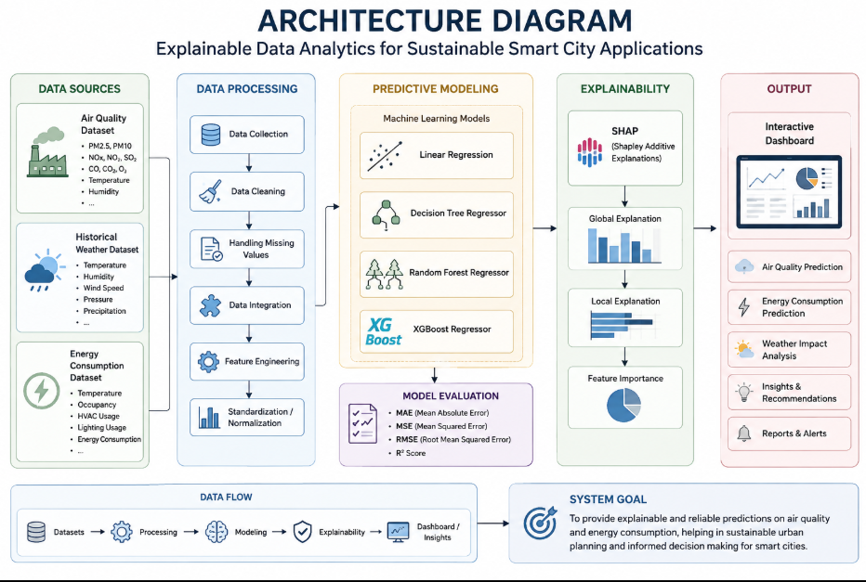

Batch No: 04
Team members
Sharmila Pathi – 2420030042
Lakshman Angara – 2420030067
Ivaturi Vennela – 2420030185
Vishnu Priya Kodali – 2420030630

